**Example for First Stage LP test**

Deposit system:

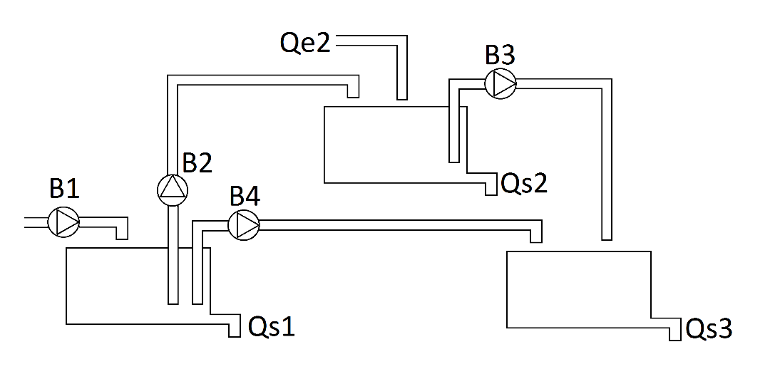

System matrix:

Dynamic matrix. Matrix nxn.

$$A=\left[\begin{matrix}0 & 0 & 0 \\ 0 & 0 & 0 \\ 0 & 0 & 0\end{matrix}\right]$$

Control Matrix. Matrix nxM.

$$B=\left[\begin{matrix}B1 & -B2 \\ 0 & B2 \\ 0 & 0\end{matrix} \begin{matrix}0 & -B4 \\ -B3 & 0 \\ B3 & B4\end{matrix}\right]$$

Disturbance matrix,

$$Bw=\left[\begin{matrix}-Qs1 & Qe2-Qs2 & -Qs3\end{matrix}\right]$$